## 

**Product Dissection for Amazon  
Company Overview:**

Amazon is one of the world’s leading e-commerce platforms, offering a range of services including online shopping, streaming, and cloud computing. Its popularity is driven by its vast selection of products, user-friendly experience, and tailored recommendations.

### **Key Features:**

1. **User Accounts and Profiles:** Personalized accounts allow users to track orders, manage addresses, and view purchase history.
2. **Product Catalog:** A comprehensive list of products categorized by department with descriptions, reviews, and ratings.
3. **Search and Recommendation System:** Allows users to search for products and receive personalized recommendations.
4. **Shopping Cart and Checkout System:** Enables users to add items to a cart and purchase them through secure payment options.
5. **Order Tracking and History:** Users can track the status of their orders and view past purchases.

## **Product Dissection and Real-World Problems Solved by Amazon**

Amazon addresses several real-world challenges through its key features:

1. **Convenience in Shopping:** Amazon's user-friendly platform allows customers to shop from a vast catalog anytime, anywhere.
2. **Personalization:** Amazon’s recommendation system tailors product suggestions, enhancing the user experience and boosting sales.
3. **Reliable Delivery and Order Tracking:** Amazon provides real-time order tracking, reassuring users about delivery status.
4. **Secure and Easy Payment:** Amazon supports multiple payment methods, ensuring a seamless checkout experience.
5. **Product Reviews and Ratings:** The review system allows users to make informed purchase decisions based on previous buyers’ feedback.

## **Case Study on Real-World Problems and Amazon's Approach**

### **Problem 1: Finding Desired Products Efficiently**

* **Challenge:** With millions of products available, users can struggle to find what they want quickly.
* **Amazon’s Solution:** The platform’s search algorithm, filters, and recommendation engine streamline the product discovery process, enhancing ease and speed of shopping.

### **Problem 2: Building Customer Trust in Online Shopping**

* **Challenge:** Online shoppers may hesitate due to lack of physical product inspection.
* **Amazon’s Solution:** By offering verified product reviews and a clear return policy, Amazon helps customers make informed decisions, fostering trust.

### **Problem 3: Seamless Transaction Process**

* **Challenge:** Shoppers need a smooth checkout experience for high customer satisfaction.
* **Amazon’s Solution:** Amazon integrates various payment options, one-click checkout, and secure transaction protocols, making the buying experience quick and safe.

## **Schema Design Based on Top Features**

### **Key Entities and Attributes**

Here’s a schema outline based on Amazon’s core functionalities:

1. **User**
   * **Attributes:** UserID, Name, Email, Address, PhoneNumber, AccountCreationDate, OrderHistoryID, CartID
   * **Relationships:**
     + **One-to-Many with Orders** (a user can place multiple orders)
     + **One-to-Many with Reviews** (a user can leave reviews on multiple products)
2. **Product**
   * **Attributes:** ProductID, Name, CategoryID, Price, Description, StockQuantity, Rating, ReviewCount,OrderID
   * **Relationships:**
     + **One-to-Many with Reviews** (a product can have multiple reviews)
     + **Many-to-Many with Orders** (a product can be part of multiple orders)
3. **Order**
   * **Attributes:** OrderID, UserID, OrderDate, TotalAmount, PaymentStatus, ShipmentStatus
   * **Relationships:**
     + **Many-to-Many with Products** (each order contains multiple products, and each product can be part of multiple orders)
4. **Review**
   * **Attributes:** ReviewID, UserID, ProductID, Rating, Comment, ReviewDate
   * **Relationships:**
     + **Many-to-One with User** (each review is written by one user)
     + **Many-to-One with Product** (each review is associated with one product)
5. **Cart**
   * **Attributes:** CartID, UserID, TotalItems, TotalPrice
   * **Relationships:**
     + **One-to-Many with User** (a user has one cart)
     + **Many-to-Many with Products** (a cart can contain multiple products, and each product can be in multiple carts)
6. **Category**
   * **Attributes:** CategoryID, Name, ParentCategoryID (for subcategories)
   * **Relationships:**
     + **One-to-Many with Products** (each category has multiple products)

## **Rationale Behind the Design**

The schema reflects Amazon’s goal of creating an efficient, user-friendly experience:

* **User and Order Entities:** The **User** entity links with **Order** and **Cart**, capturing individual purchase behavior and cart interactions to enhance personalization.
* **Product Entity:** Designed to support extensive search and filtering, this entity links to **Review** and **Category** for better organization and feedback.
* **Review Entity:** Encourages trust by allowing user feedback, linking **User** to **Product**.
* **Category Entity:** This hierarchical organization of products makes it easy for users to browse products efficiently.

## **ER Diagram**

Using an ER diagram tool like Miro or Lucidchart, you can illustrate the relationships between these entities. Here’s a quick outline for your ER diagram:

1. **User → Order:** One-to-Many
2. **User → Cart:** One-to-One
3. **Product → Review:** One-to-Many
4. **Order → Product:** Many-to-Many (using a junction table)
5. **Cart → Product:** Many-to-Many (using a junction table)
6. 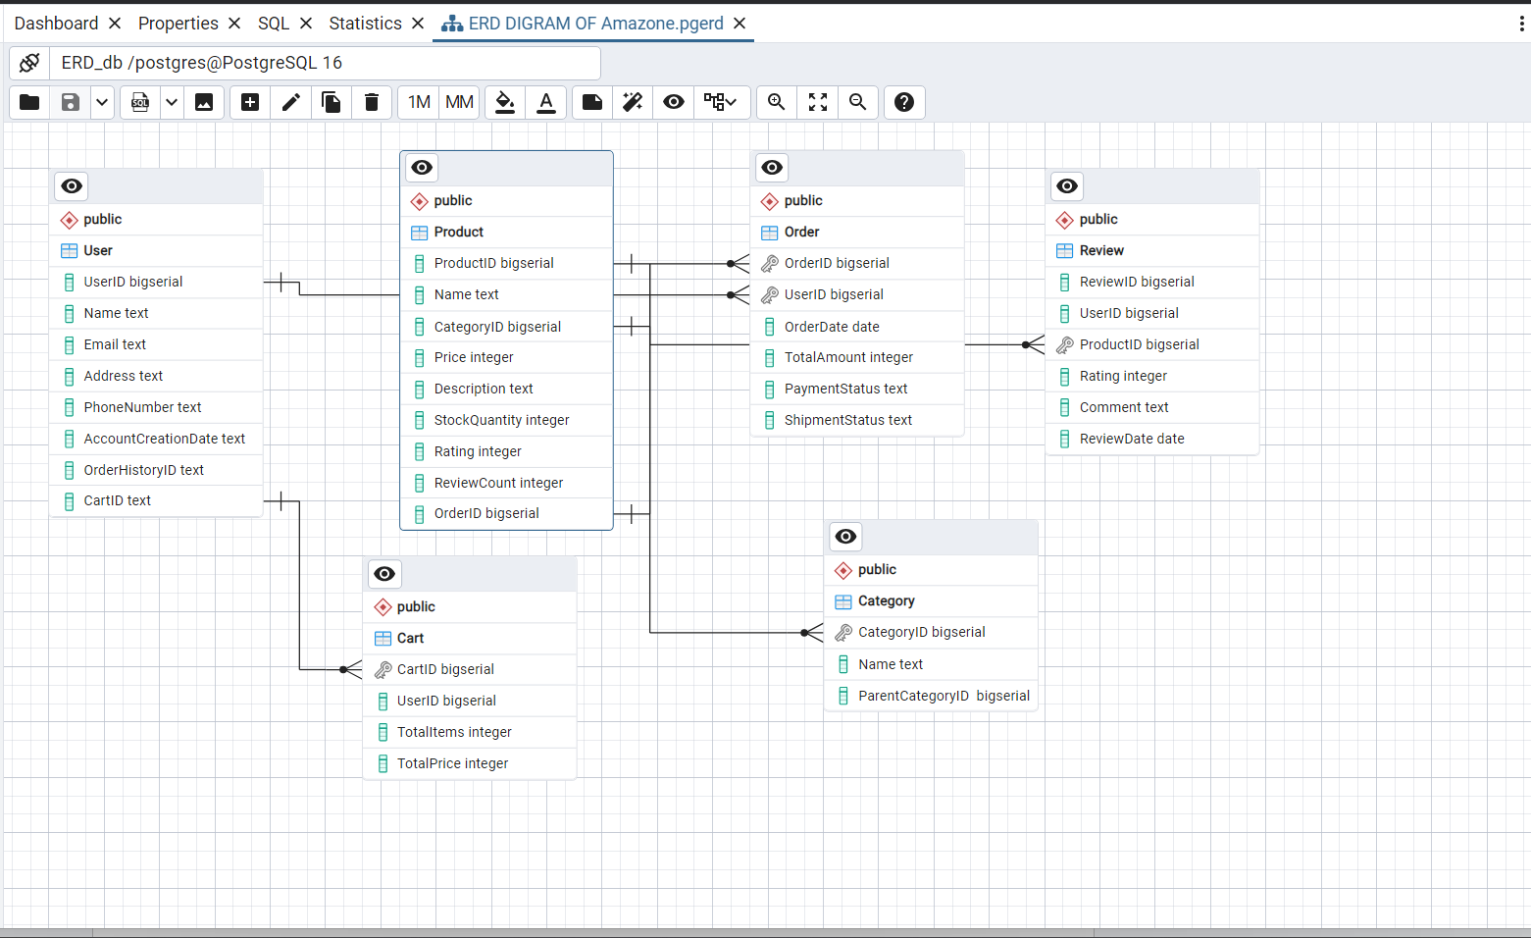

## **CONCLUSION :**

In this case study we delved into a design of amazon.com’s schema. Although there are many more features and entities within the website, the main ones serving as the backbone of the enterprise are represented. The e-commerce platform's intricate design of a data model consisting of entities like product, category, cart, customer, address, orders and payment has been highlighted. By examining the schema we can understand how the physical entities are transformed into a database forming a backbone of the platform.

## 